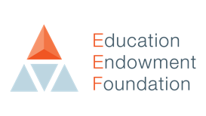
MOVING FORWARDS, MAKING A DIFFERENCE:
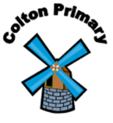
Colton Primary School Pupil Premium 3 Year strategy 2025-2028
To ensure access to high quality teaching, we will use:
Early Reading:
- RWinc programme to train all staff and ensure consistency (Phonics lead to continue to review and ensure staff access training)
- Phonics lead (supported by RWinc programme) monitors all staff are teaching to a high standard
- CPD through Jerry Clay English Hub (DFE reading fluency – the bridge to comprehension)
Personal Development:
- The new personal development programme ‘One Life’ to train all staff to teach SEMH well.
- Forest School specialist to teach outdoor learning sessions across school.
1. HIGH QUALITY TEACHING
To deliver impactful targeted support, we will use:
- Lexia programme: bespoke personalised learning to those vulnerable to under achievement in reading
- Small group tuition in English and Maths (delivered inhouse either by teachers or experienced HLTAs as we found this was more impactful)
EYFS
- EYFS staff continuing to develop their communication and language approaches by working closely with SALT to implement assess and deliver quality S&L interventions

- Our new pastoral lead, who is ELSA trained, will deliver bespoke SEMH intervention groups.

2. TARGETED ACADEMIC SUPPORT
Remove non-academic barriers to attainment by:
- Making links with parents and carers to support anxiety and self esteem
- Improving attendance through supporting parents to manage anxiety-based absence
- Subsidised enrichment, such as: educational visits, after school clubs, holiday clubs and opportunities for extra music tuition
- Access to a full school uniform

- Give disadvantaged pupils access to experiences and opportunities in and out of school (e.g. live music performances)

3. WIDER STRATEGIES

