

‘Everyone Successful Everyday’

Headteacher: Mrs. Caroline Johnson Colton Primary School
NPQEL NPQH BSc Cert Ed SLE AST School Lane
Tel: (0113) 2647514 Colton
Email: info@cps.rklt.co.uk Leeds
L15 9AL
Dear Parents/Carers 23rd October 2025
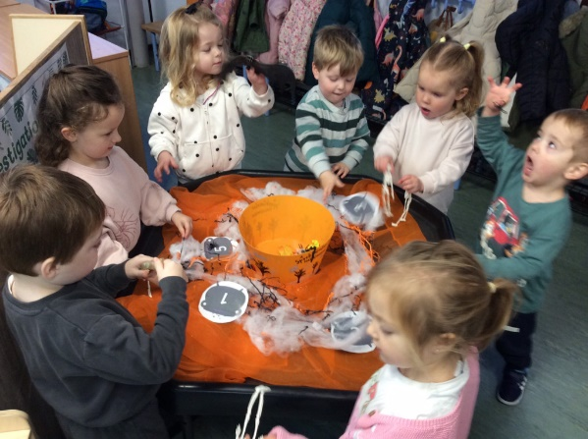
What a wonderful half term! The children have settled into their new classes and have worked very hard.
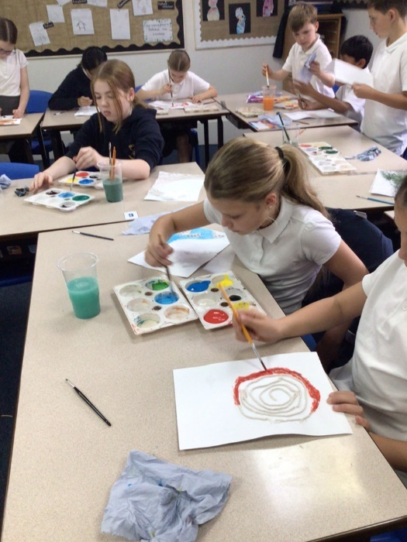
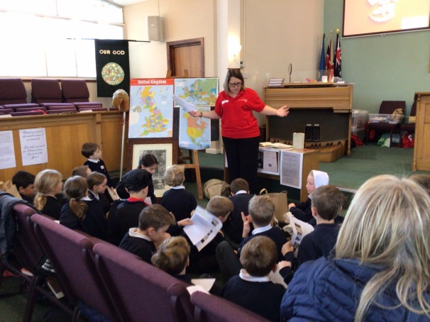
Some exciting things we have been up to are…
Nursery and Reception have been carving pumpkins, counting spiders and other spooky things! Year 4 visited a church and learnt all about the life of John Wesley and the Methodist Church. Year 6 have been enjoying their natural disaster themed art lessons based on the work of Stephanie Peters.
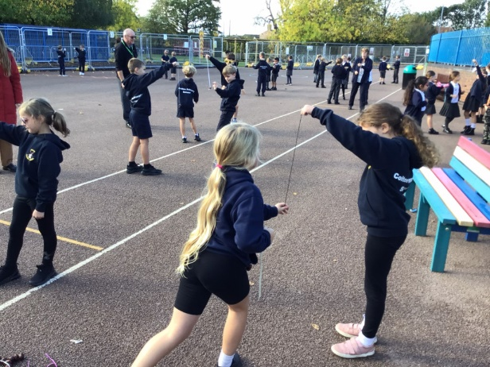
Conker Competition
We hope the children enjoyed playing conkers with their friends. Many had never heard of it. However, most of the adults remembered playing at school – minus the gloves and glasses for protection!
Perhaps this will become a new annual event? Let us know what you think on Tapestry.
PTA
We continue to be grateful to our PTA for all their support – whether they are planning exciting visits, organising a disco or film night. When your son or daughter joins Colton, you are automatically a member! I am sure you are pleased to know it is absolutely free . We are thrilled that so many new parents have recently joined and this will ensure we can keep offering our children a great experience at Colton. The Halloween themed dress-down day was a huge success. The children loved dressing up – and the sweeties at the end of the day. Thank you all so much for your support.


RKLT Youth Board
Children from across the Trust have been discussing global issues, sustainability and the environment. One of our pupils, Verity in Y4, had the opportunity to share her entrepreneurial journey with the Youth Board. She also shared her experience as a first time author, which is quite an achievement at 8 years old. The Board were very impressed with her public speaking skills.
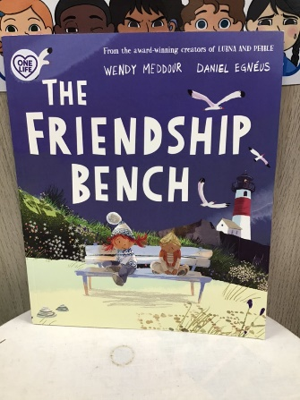
One Life
It has been wonderful to see the children adapting to the ‘soft start’ to the school day. Pupils are arriving with huge smiles on their faces. Staff are enjoying greeting the children and giving them just 10 minutes to chat to their friends, empty their thoughts into their journal and focus on the day ahead.
Most of the lessons are based on lovely stories. This one was read in Reception and the children then shared their ideas about what makes a good friend.

As part of One Life, we are also supporting children to develop their emotional understanding and how to recognise and mange their feelings. The One Life curriculum will help the children to develop these skills for life. Although we are at the very beginning of this way of working, the children are already thinking about their feelings in different ways. For example, the children may say things like “we are not our thoughts” or that they are going to “catch themselves.” The children are also understanding the benefits of deep breathing to calm their mind. More information will follow next half term as we continue our Onelife journey.
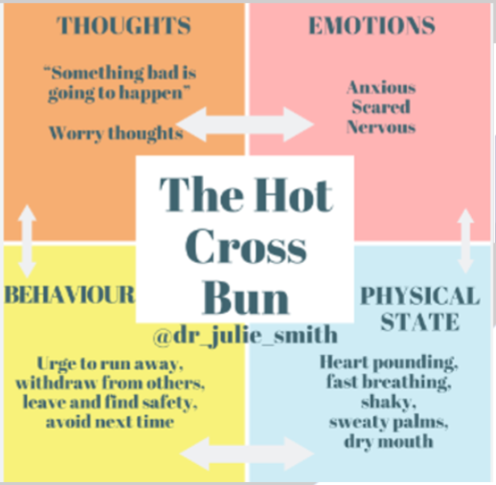
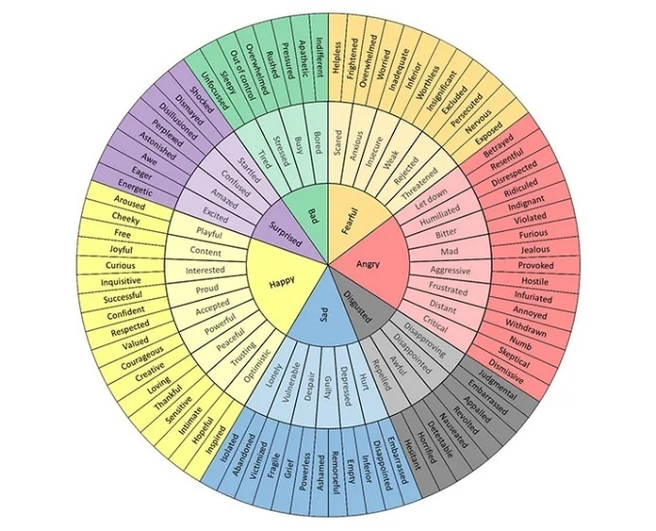
Our Feelings Wheel

The ’Hot Cross Bun’ Reflection Tool

Staffing Update
We are pleased to announce that Mrs Laura Shepherd will be joining us as our Pastoral Lead after the half-term holidays.
Mr Lotherington, the Caretaker has decided to accept another role. We wish him all the very best and will be recruiting for the role shortly.

New Kids Club Building – update
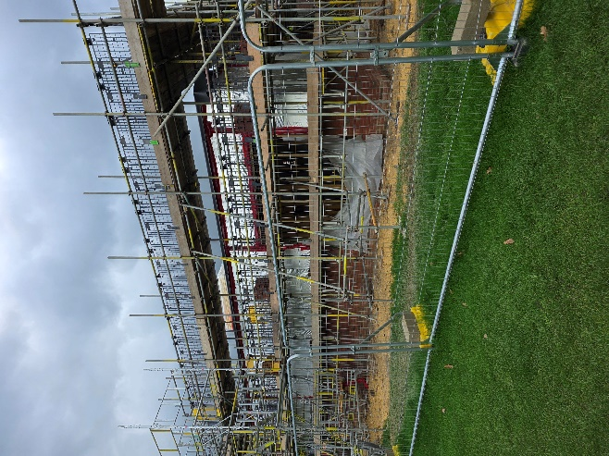
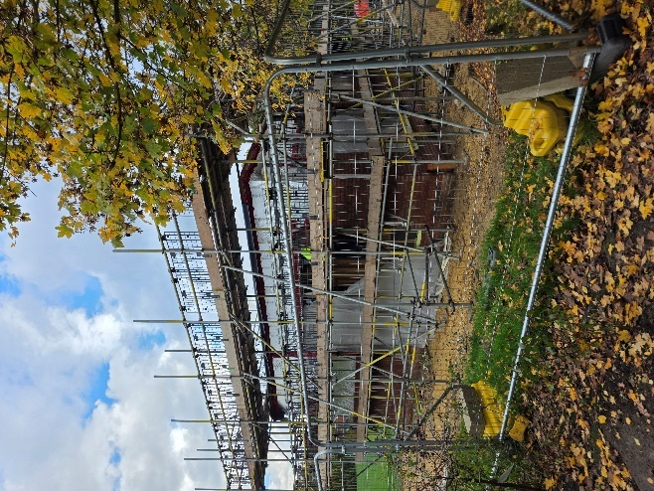
The children are enjoying watching the lorries and machinery coming and going on the playground. The building work is continuing. At the moment, it is on track to be finished in February which is very exciting. Thank you for your continued support and patience as we use the school hall for Kids Club. We do still have some places available. Wrap around runs from 7:30am to 6pm and any pupil can attend from Nursery to Year 6. If you would like any more information, please email: coltonkidsclub@cps.rklt.co.uk or speak to the School Office.

Polite Reminders:
Uniform – please see the full Uniform Policy on the website for details - colton.org.uk/seecmsfile/?id=999
Key things to remember:
Children do not need to have ‘school shoes’ but if trainers are worn instead, these must be plain black – no markings.
Uniform does not need to have the Colton logo on it – Sainsbury’s / Tesco / Matalan school uniform fine. Second hand uniform is available via the uniform swap Facebook group.
Children are not allowed to wear nail polish, jewellery (other than a watch – not a smart watch – and one pair of stud earrings).
Hair – no lines, colours or shapes and patterns. Hair accessories should be small, discrete and in school colours – navy, white or black.
No branded PE clothing please. If children bring PE kit to school which does not meet the uniform requirements, we will ask them to wear our spare PE kits.
PE shorts must be knee length cycling shorts / mid-thigh – not revealing buttocks.
If children have their ears pierced, please ensure earrings are removed for PE lessons. We follow the latest guidance which does not recommend putting plasters over earrings. If you choose to do this, we are not able to take responsibility for any subsequent accidents involving their ear lobes.
Please ensure names are in everything as it will help us to get lost property back to your children.
The school playground is a phone free zone. If parents / carers need to take a call around pick up or drop off, we politely ask that you end the call before entering the playground.
We need to make sure all children and adults feel safe on the school grounds. Year 5 and 6, who sometimes bring phones to school so they can contact parents when walking home independently, must not use their devices on the playground. This ensures we are in line with the latest national updates in the Keeping Children Safe in Education Guidance. Thank you in anticipation of your support.
Phone Free Zone



Training Days for 2025-2026
School will be closed to pupils on the following days:
Friday 24th October 2025 | Monday 5th January 2026 | Friday 3rd July 2026
Monday 20th July 2026 | Tuesday 21st July 2026

Kind regards,







Mrs Caroline Johnson
Dates for your Diary
Date | Activity
24/10/25 | Training day (INSET day when children are not in school)
27/10/25 | Half term – school closed to pupils
3/11/25 to 14/11/25 | Assess Plan Do Review Meetings – Invite only
Week Beg 10/11/25 | Anti-Bullying Week
10/11/25 | NHS Height and weight measurements Reception and Year 6 in school.
7/11/25 | Year 5 Parent workshops – 9am (Details TBC)
14/11/25 | BBC Children in Need tomorrow (arrangements TBC)
14/11/25 | Year 3 and Year 4 Parent workshops - 9am (Details TBC)
19/11/25 & 20/11/25 | Parents / Carers Target Setting Evenings
21/11/25 | Year 2 Parent workshop – 9am (Details TBC)
28/11/25 | Year 1 and Reception Stay and Play – 9am (Details TBC)
9/12/25 | Y 4/5/6 Christmas Performance 1:20pm
9/12/25 | Y 1/2/3 Christmas Performance 2:20pm
10/12/25 | PTA Christmas Pop Up Shop
10/12/25 | EYFS + Christmas Performance (All nursery children can attend) 9:30am
11/12/25 | Y 4/5/6 Christmas Performance 9:15am
11/12/25 | Y 1/2/3 Christmas Performance 10:15am  EYFS Christmas Performance 1.20pm
15/12/25 | Christmas party days  Tues PM – Y1/ 2  Fri PM– Y5/6  Friday AM – Y3/4
16 /12/25 | Elf Run – Details to be confirmed
17/12/25 | Christmas Jumper Day and Christmas Dinner
17/12/25 | PTA Christmas pop up shop (subject to volunteers)
18 /12/25 | Carols at Whitkirk Church 10 am (TBC)
22/12/25 - 2/1/26 | Christmas break – School Closed to pupils
05/01/26 | Training Day – School Closed to Pupils

